**CSS (Cascading Style Sheets)**

CSS is used to implement style in our web pages. We have actually three ways of doing this first is

**Inline CSS** in this we actually write the style itself in the tags like Jhan body me background colour ya background image ki jarurat hai to usi mai sidhe tag dal ke kar diya. Par isse agr apko apke sare page mai same type of theme ko implement karna hai to wo nhi ho pta hai,

**Example: <tagname(eg body, h1, div, etc) style="background-color: red">**

**Internal CSS**  in this we basically define the style for the page mtlb ki hmne head ke upr ek alg se <style> </style> ke bich mai hm define karte hai themes ko and wo pure ke pure pe broadly rhta hai implemented .

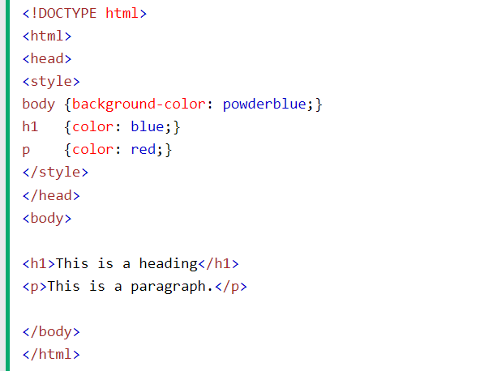

**External CSS** in this we actually make a css file outside the html file ad then link that to our rewuired page using link tag that is as given <link rel = “stylesheet” href = “/css/cssfilename.css”>

However, all the strongest preference ka order inline then internal and then external means ki agr inline and internal define hai dono to bhi inline ka hi use karega wo block whi local ka use hota hai global ka nhi.

Now lets see once the syntax of css file.

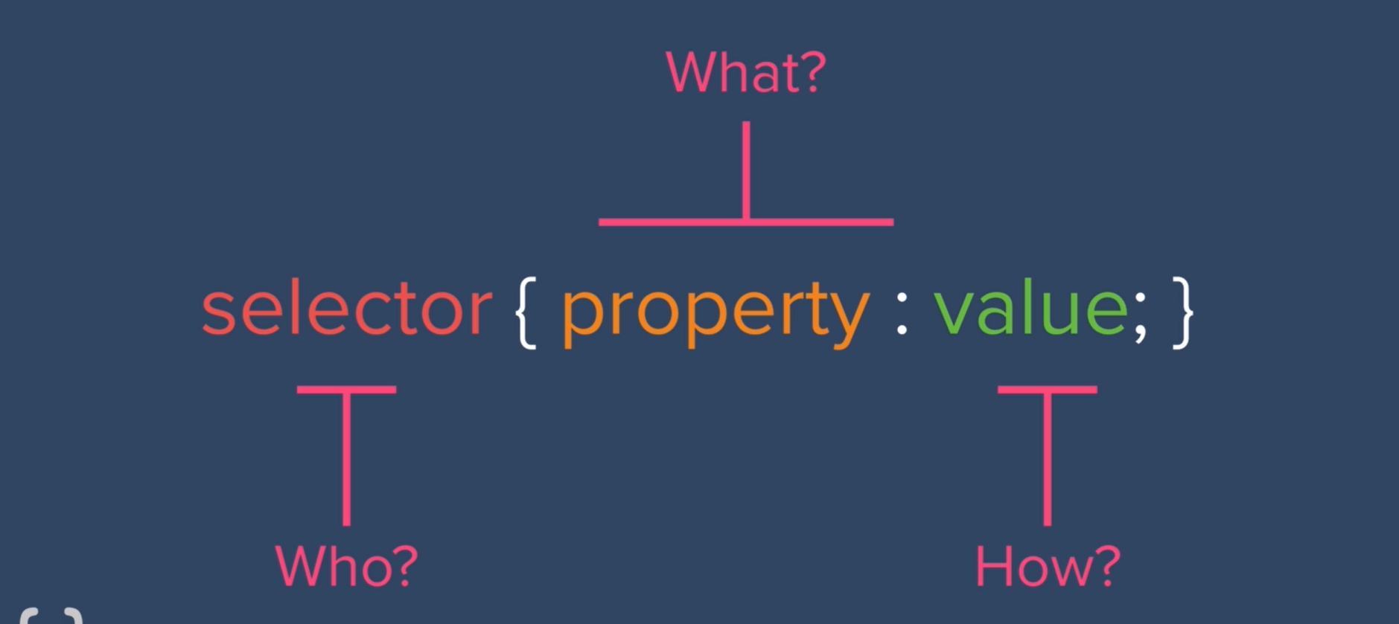

Example of the css how we do actually and this method of defining is called **tag selector** ki aap pure tag ko genralize karke hi sab kuch implement kar dete hai.

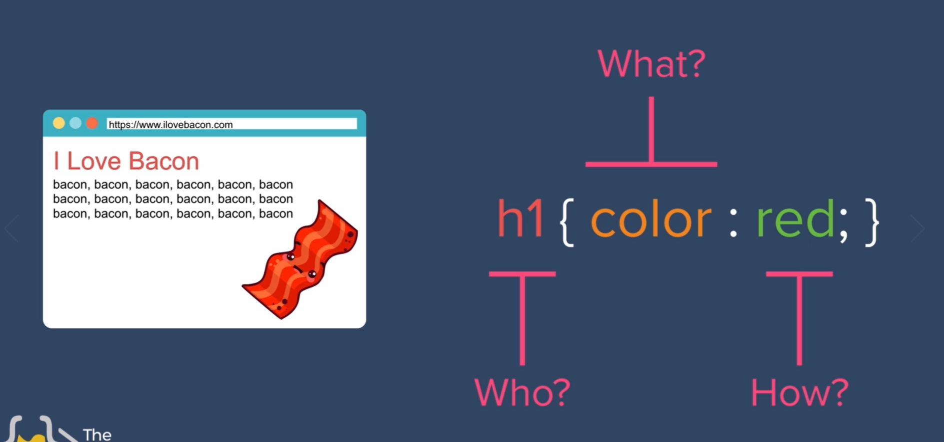

Now in case agr apke pas multiple image hai and ek pe aap ye style and dusre aap wo style dena chahte hai to us case mai kya karte hai ki hm phle to us tag ko sepratelg alg se ek class keyword se uska class define kar dete hai and then iske abd hm phir us class ka koi nam dete hai and while defining in css file we define classselctor and wo kese hota hai to **.classname** jo bhi class name apne diya hai and then aage ka kar do and ye sab ke sath kar skte ho sirf img ke sath hi nhi

First define class

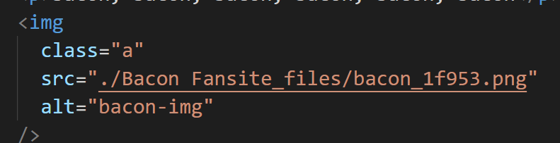

This is **class selector**



Same way hmare pas **ID selector** bhi hota hai yha class mai .classname karte hai Id selector ke liye #idname karte hai to difference kya hai to point s ki jab aap id ka use karte hai to ek id ke do jgh object nhi ho skte ek id ek hi tag ko reference karega while class can do a lot.

How we define id



And how we define id selector

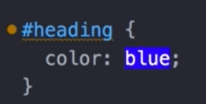

Eg ki tag selector hua pura global wo sare jitney bhi image pe apply hona chahta hai. class selector hua thora sa local usme wo jese ki jitney bhi dp ho unka border cicle rkhna hai wo dekh liya aab. id selector thora aur specific hoke wo usi ek image ki hi bat karega

And whi sbse superior id ka call hai agr agr id selector defined hai to class aur tag selector ignore hoga

**Multiple class refernece**

Agr hmne space dal ke ek se jada name mention kiya hai “classa classb ” ke andr to it means ki wo multiple classes ko reference kar rha hai and aap .classa{} mai jo likhoge wo bhi aur .classb{} mai bhi jo likhoge wo dono hi apne mai wo implement karega.

So in class you can inherit two class



And define class selectors separately and both will be used.

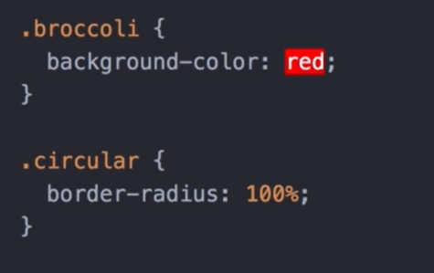

Key point ye aap id ke sath nhi kar wo ek bar mai ek hi ho skti hai object ki id no multiple allowed.

**Psudo class:**

Pseudo class mai aap kya karte hai ki aap tag ya class ke sath hi use karte hai us pseudo class ko example hover and ye apko allow karta hai kuch special feature ko implement karne ko like color change 0n hover type chije. There are a list of such function

Multiple class inherited

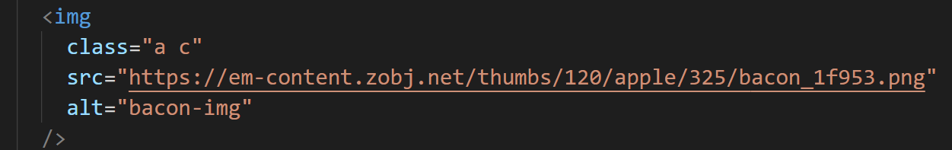

And this is how we define psedo class selector

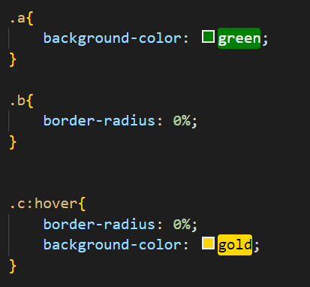

**Favicons** to create a faviocon



These icons can be linked to your site using

<link rel="icon" , href="relative address of icon" />

Somebody I used to know

Somebody I talked too more

I lost them now in middle of the show

Somebody I talked so long

Somebody I found in town

I lost them in middle of the row

I hoped things will change soon

But its bad next morning in the